Linux

1. **Open Source**
   1. **Linux Evolution And popular Operating Systems**
2. **Linux Distributions**

**Distributions:**

A distribution is a collection of components that form a system

Graphical Interface

X Server

GNU core

Linux Kernel

Hardware

**Hardware:**

The hardware is the physical device being used as **compute** resource. This device will include some form processing capability, as well as short-term and long-term data storage.

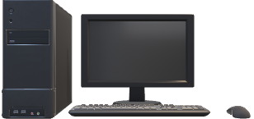

The Linux Distribution is installed as an **operating system** onto the provided hardware

**Linux Kernel:**

* The Linux Kernel is a free and open source operating system kernel.
* Kernel is the framework that connects the application layer to the hardware of a computer
* Within this low-level abstraction process, system calls are made to the kernel

**GNU Core Utilities:**

The GNU core utilities are the basic file, shell, and text manipulation utilities of the GNU operating system.

These are the foundational utilities expected to exist on every operating system.

**Examples** include : set and change file permission and ownership, concatenate and write files, exit status, listing directories and files

**X Server:**

The X server is the display server for the X windows system; a framework for the GUI environment.

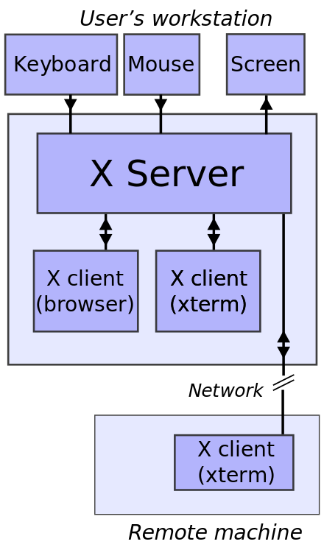

[This Photo](https://unix.stackexchange.com/questions/303515/how-to-control-windows-10-via-linux-terminal) by Unknown Author is licensed under [CC BY-SA](https://creativecommons.org/licenses/by-sa/3.0/)

X is an architecture agnostic framework for remote graphical user interfaces and input devices

**Graphical user Interface:**

The Linux GUI is often referred to as a Desktop environment.

Common Linux desktops include **Gnome, KDE, Unity, Cinnamon, MATE, and Xfce,** though there are many others.

This is the environment that permits you to navigate the operating system using a mouse and folders.

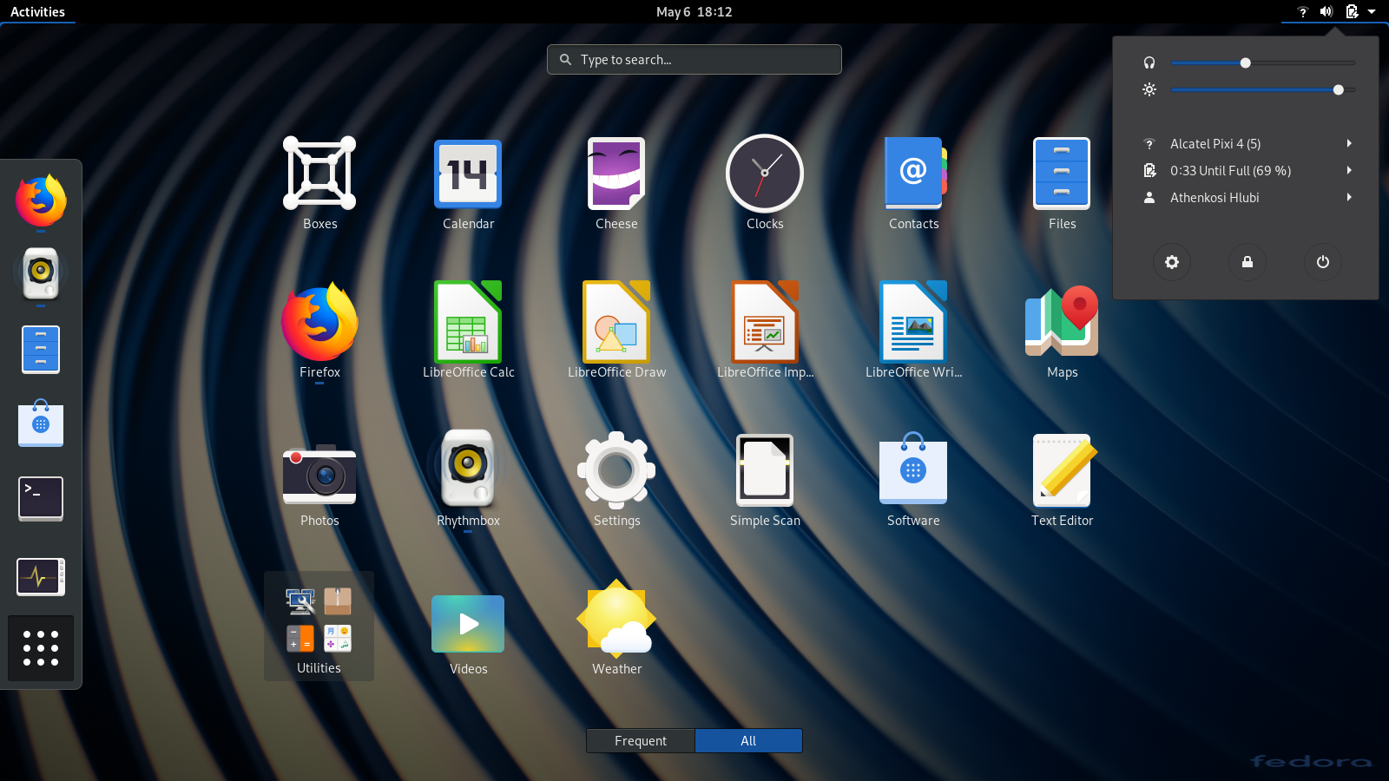

Gnome Desktop

**Popular Linux distributions:**

* Red Hat Enterprise Linux
* CentOS
* Ubuntu
* Fedora
* Debian
* openSUSE

